Field Force Connect – API Testing Report
Tester Information
Tester Name: Prathmesh Nikam
Role: QA Tester (2 Months Experience)
Testing Tool: Postman
Application: Field Force Connect
Test Date: 3 September 2026

Introduction
As part of this assignment, I performed API testing on the Field Force Connect application using Postman. The objective was to identify the Login and Add Customer APIs, configure the Postman environment, and validate the application's functionality through GET and POST requests.

Environment Configuration
A dedicated Postman environment was created to avoid hardcoding URLs and authentication values.
Environment Variables
Variable | Purpose
base_url | https://test.fieldforceconnect.com/api/account/authenticate
auth_token | Stores the authentication token received after login
Base URL:
https://test.fieldforceconnect.com
Using variables made the requests easier to maintain and reuse throughout testing.

Test Scenario 1: Login with Valid Credentials
Objective
Verify that a registered user can log in successfully.
Request
Method: POST
Expected Result
- User should be authenticated successfully.
- Authentication token should be generated.
- Response status should indicate success.
Actual Result
The application authenticated the user successfully and returned the required token, which was stored in the Postman environment for further requests.
Status
PASS

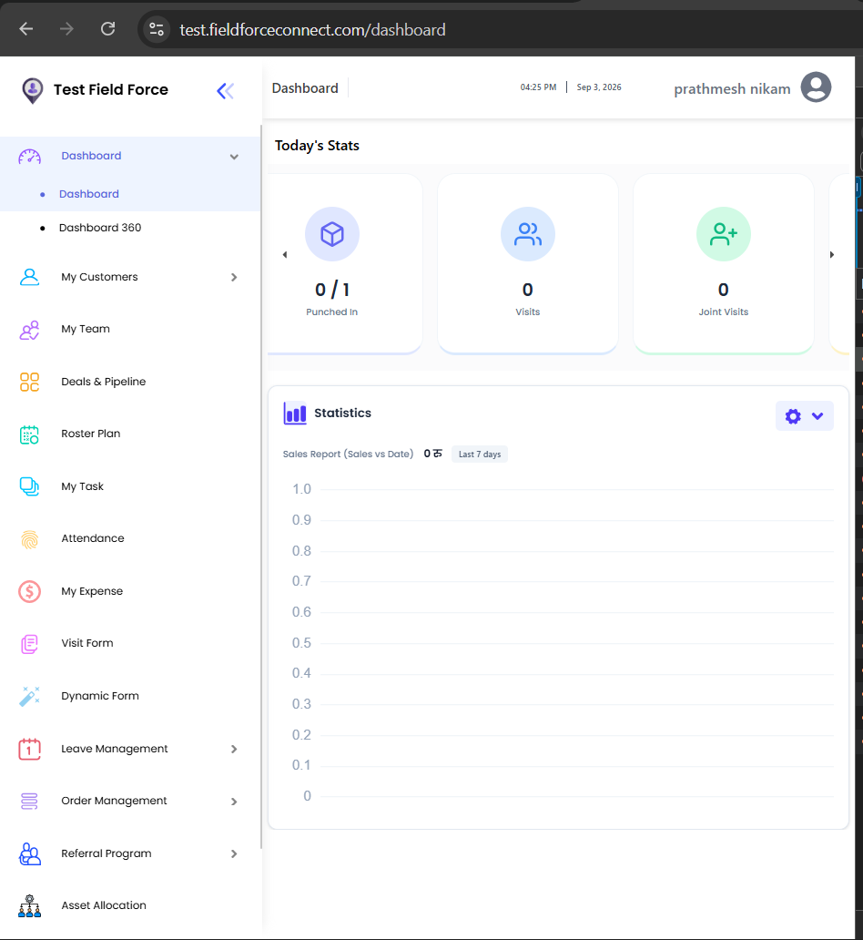

Test Scenario 2: Login with Invalid Credentials
Objective
Verify that the application handles invalid login attempts correctly.
Request
Method: POST
Expected Result
- Login should fail.
- Appropriate error message should be displayed.
- No authentication token should be generated.
Actual Result
The application rejected the invalid credentials and returned an error response as expected.
Status
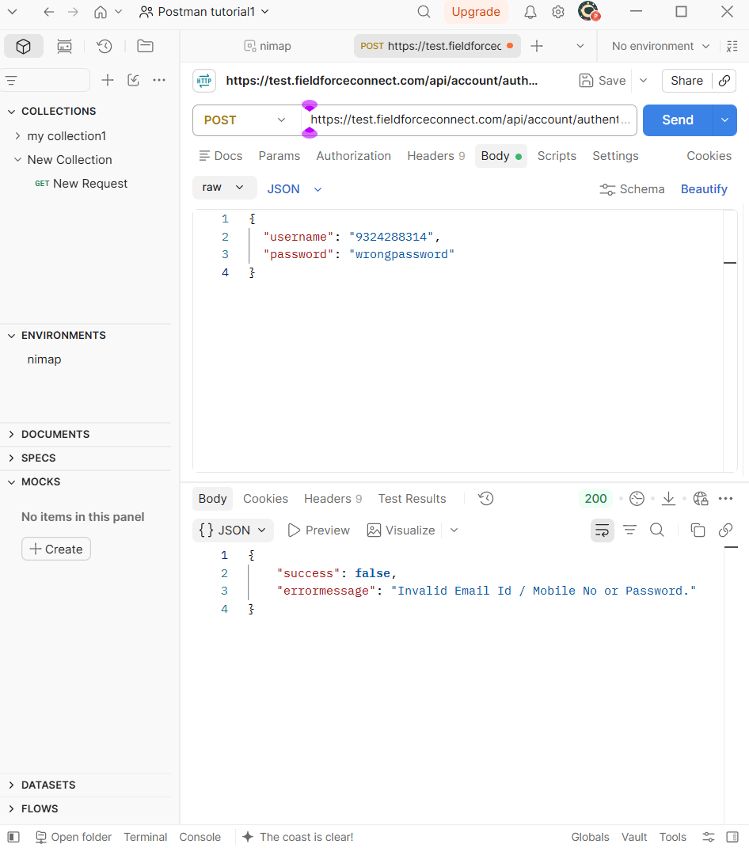
PASS

Test Scenario 3: Add Customer
Objective
Verify that a new customer can be added successfully after authentication.
Request
Method: POST
Authorization: Bearer Token
Test Data Used
- Customer Name: Test Customer
- Mobile Number: 9876543210
- Email: testcustomer@example.com
- Address: Mumbai
Expected Result
- Customer record should be created successfully.
- Success response should be returned.
Actual Result
The customer was added successfully and the API returned a successful response.
Status
PASS

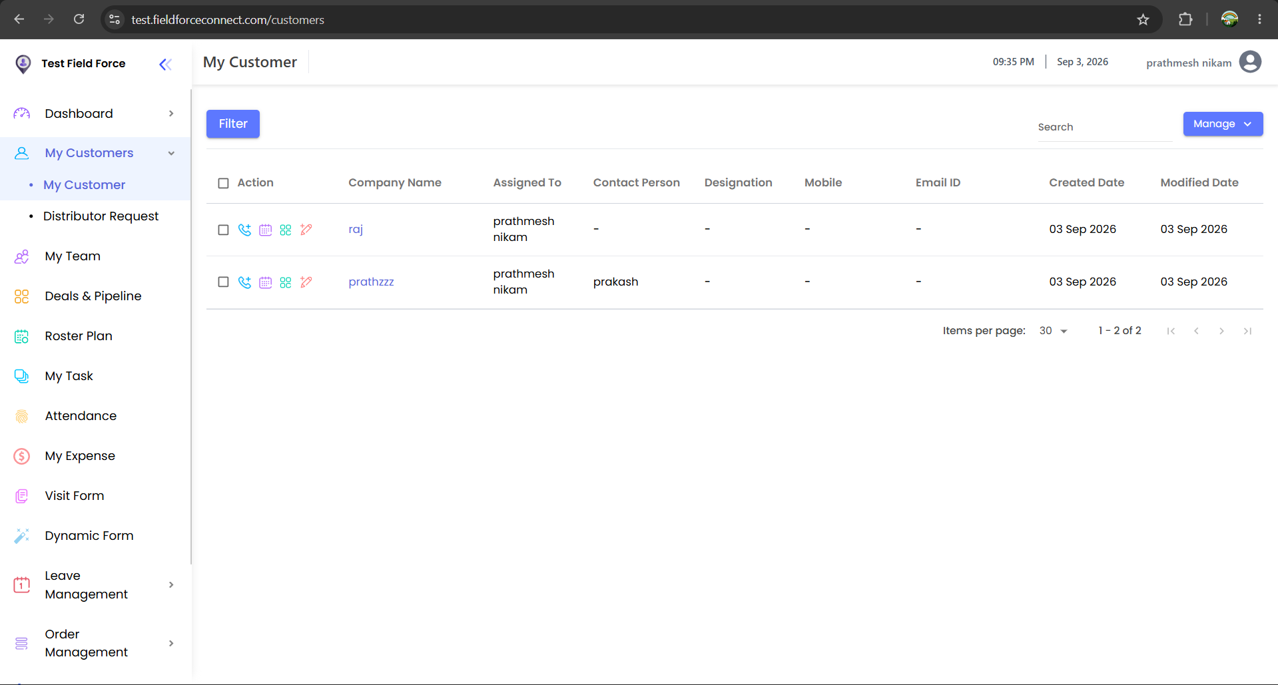

Test Scenario 4: Retrieve Customer Data
Objective
Verify that customer information can be retrieved through a GET request.
Request
Method: GET
Expected Result
- Customer records should be returned successfully.
- Response data should match available customer information.
Actual Result
Customer details were retrieved successfully through the API.
Status
PASS

Authentication Handling
The authentication token received after successful login was stored in an environment variable and reused in authorized requests.
This approach reduced manual effort and ensured consistency during testing.

Challenges Faced
- Identifying the exact API endpoints from the application.
- Understanding request payload structures.
- Verifying authorization requirements for customer-related APIs.
These challenges were resolved using browser developer tools and Postman request analysis.

Summary
The application APIs were tested successfully using Postman. Login functionality, authentication handling, GET requests, and customer creation workflows behaved as expected during testing. Environment variables and token management were implemented to improve test execution efficiency.
Overall Result
All Executed Test Scenarios: PASS

GitHub Repository
Postman Collection and supporting files have been uploaded to GitHub.
Repository Link: https://github.com/prath457/Postman-APIs.git

